https://stateparks.utah.gov/parks/goblin-valley/hiking-in-goblin-valley/

Goblin Valley State Park

- Discover
- Map
- Events
- Publications
- Amenities
- Canyoneering
- Park Fees
- Directions

Hiking in Goblin Valley
Goblin Valley State Park presents a fun and unique experience for those who wish to explore on foot. The Valley of Goblins, our most well known attraction, spans nearly three square miles and is a free-roaming area that can be explored at your leisure. Beyond this area, the park also offers six miles of hiking trails as outlined in our brochure. To learn more about one of these routes, click one of the links below. Otherwise, read on for a virtual tour of the Valley of Goblins.
The Goblin’s Lair Carmel Canyon Entrada Canyon Curtis Bench Trail Three Sisters
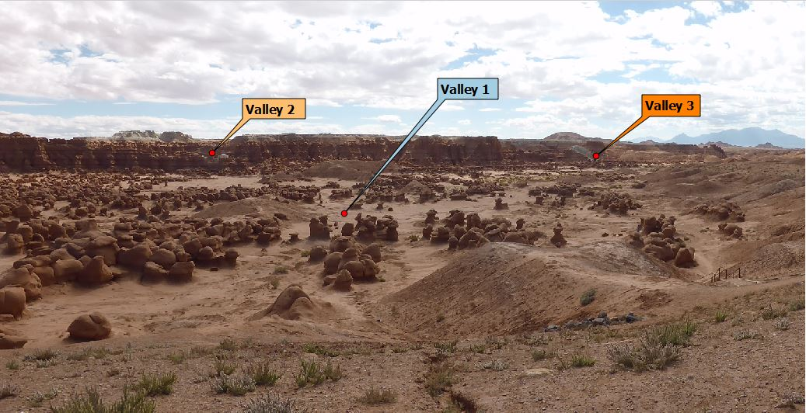
Maps of Goblin Valley State Park, including the one found in the park’s brochure, often divide the Valley of Goblins into three separate areas. The photo above reveals what that division looks like in reality. The view is from the observation point, facing southeast. After descending the staircase from the picnic pavilion, hikers will enter the First Valley: a mostly flat expanse containing several dozen clusters of the twisted, stunted hoodoos locally called “goblins.” No matter what direction a person chooses to walk here, they are sure to find something interesting.

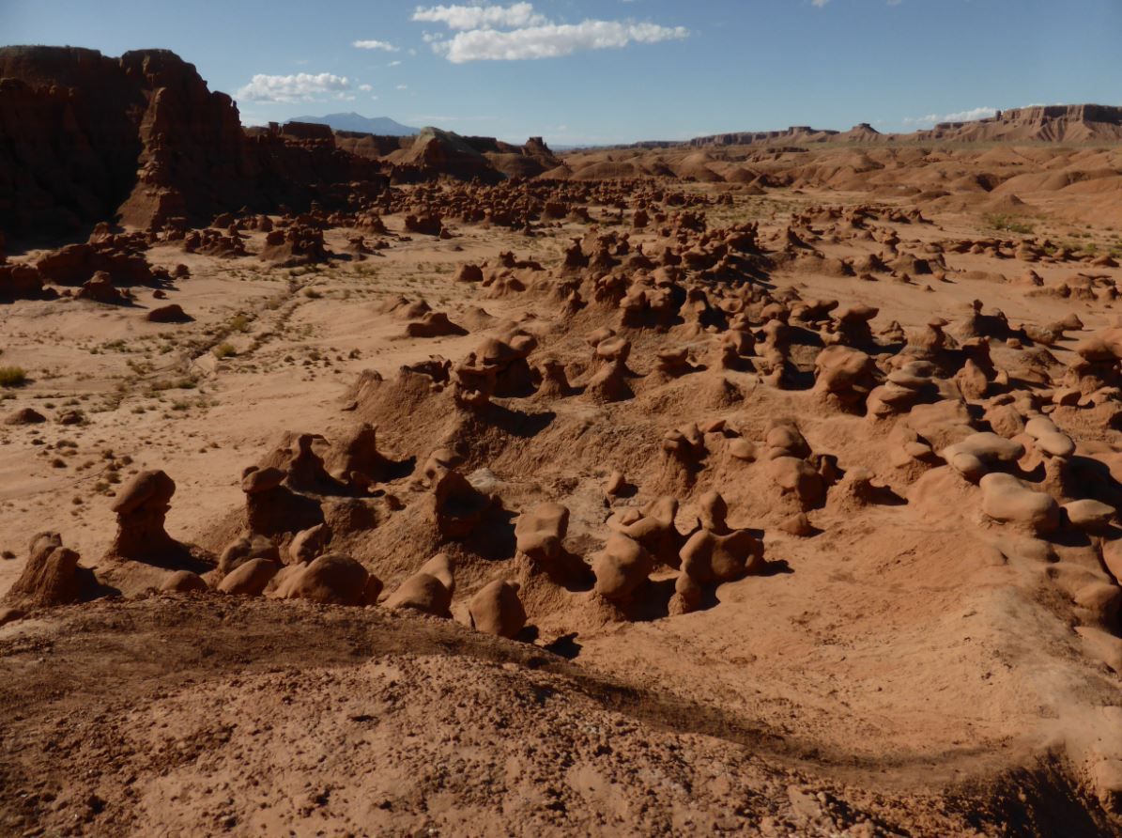
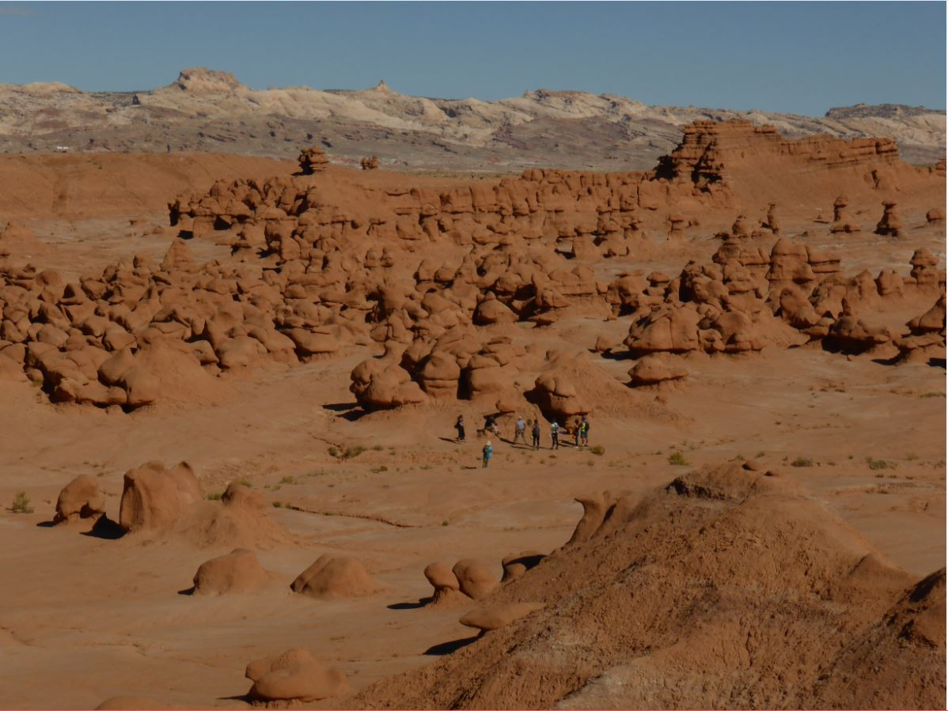
Scenes from the First Valley of Goblins
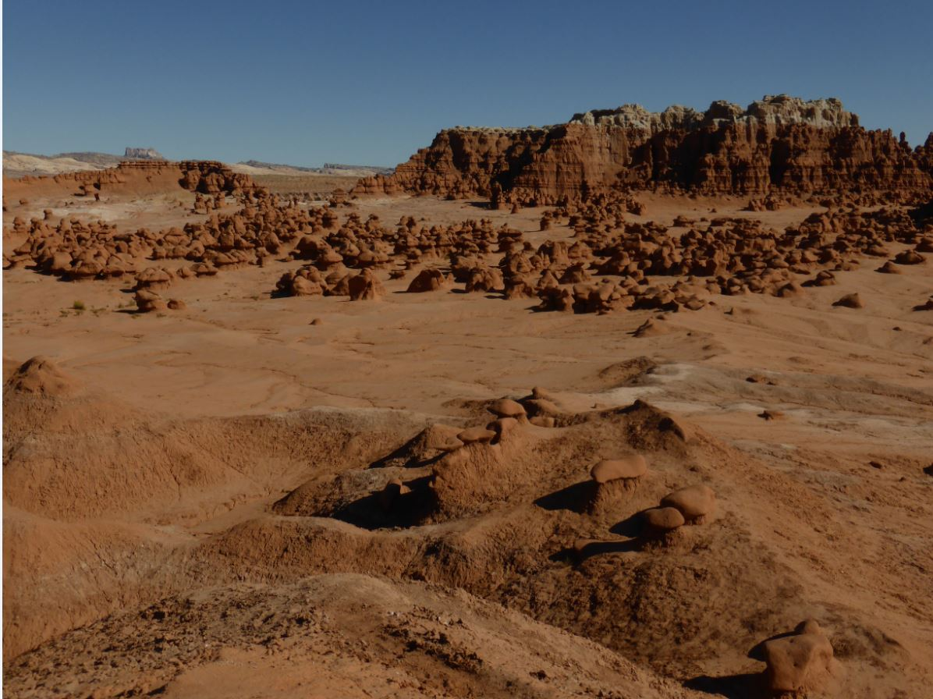

Tucked away behind a low ridge, approximately 1/2 mile from the observation point, the Second Valley of Goblins is much different in character from the first. Here, the goblins grow much taller as they line the walls of a narrow canyon. Canyoneers will pass through the second valley on their way to reach the rappelling route into The Goblin’s Lair.

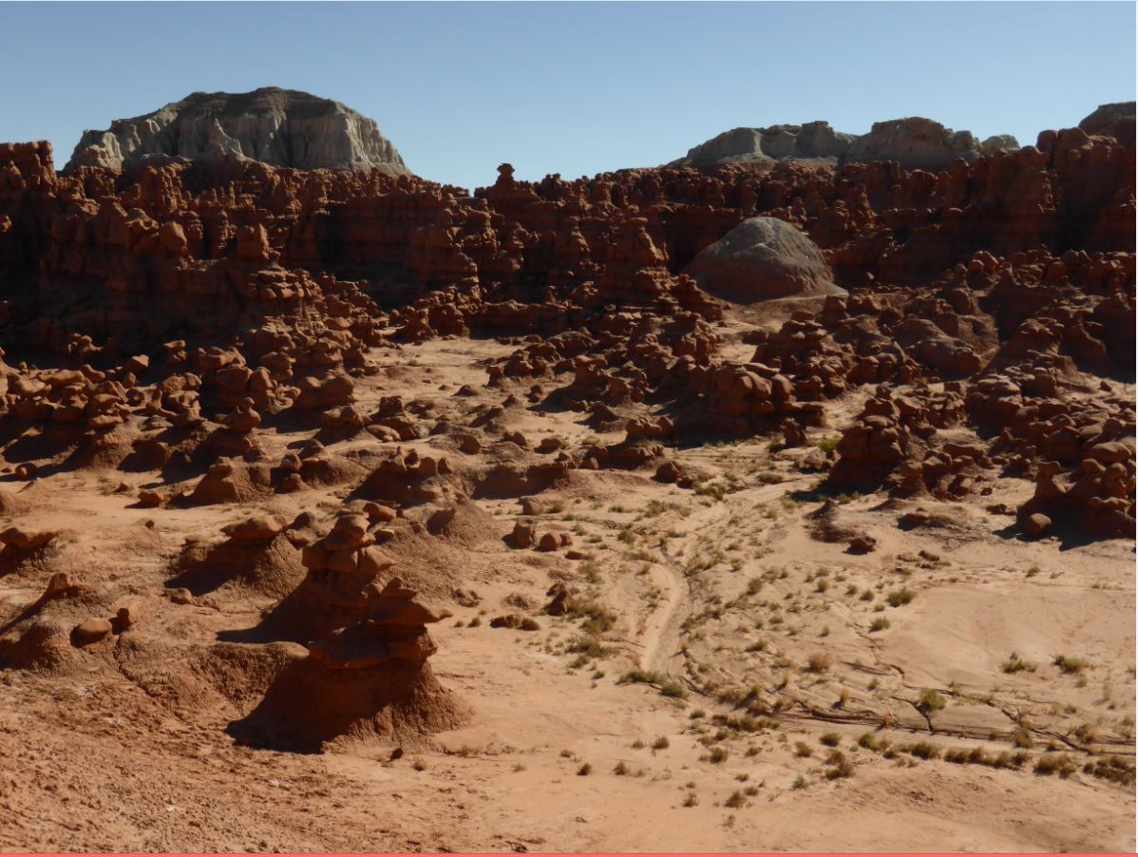
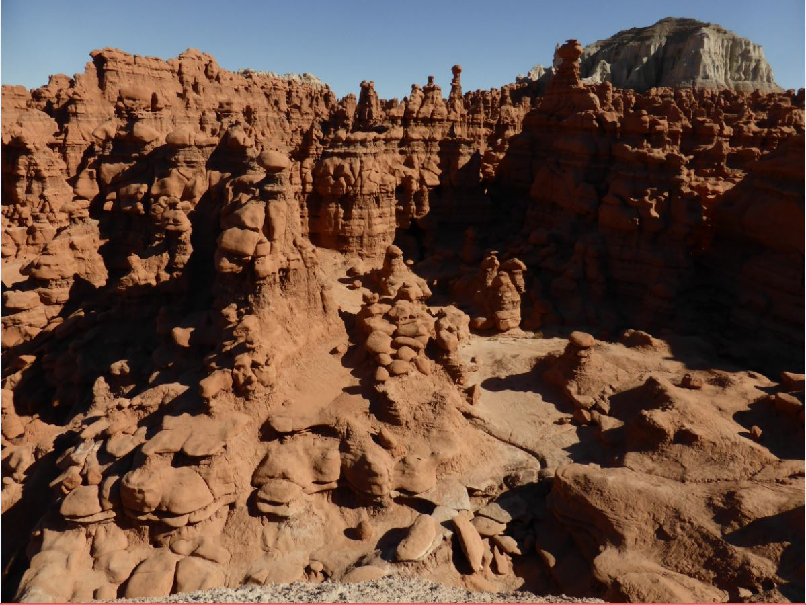
Scenes from the Second Valley of Goblins
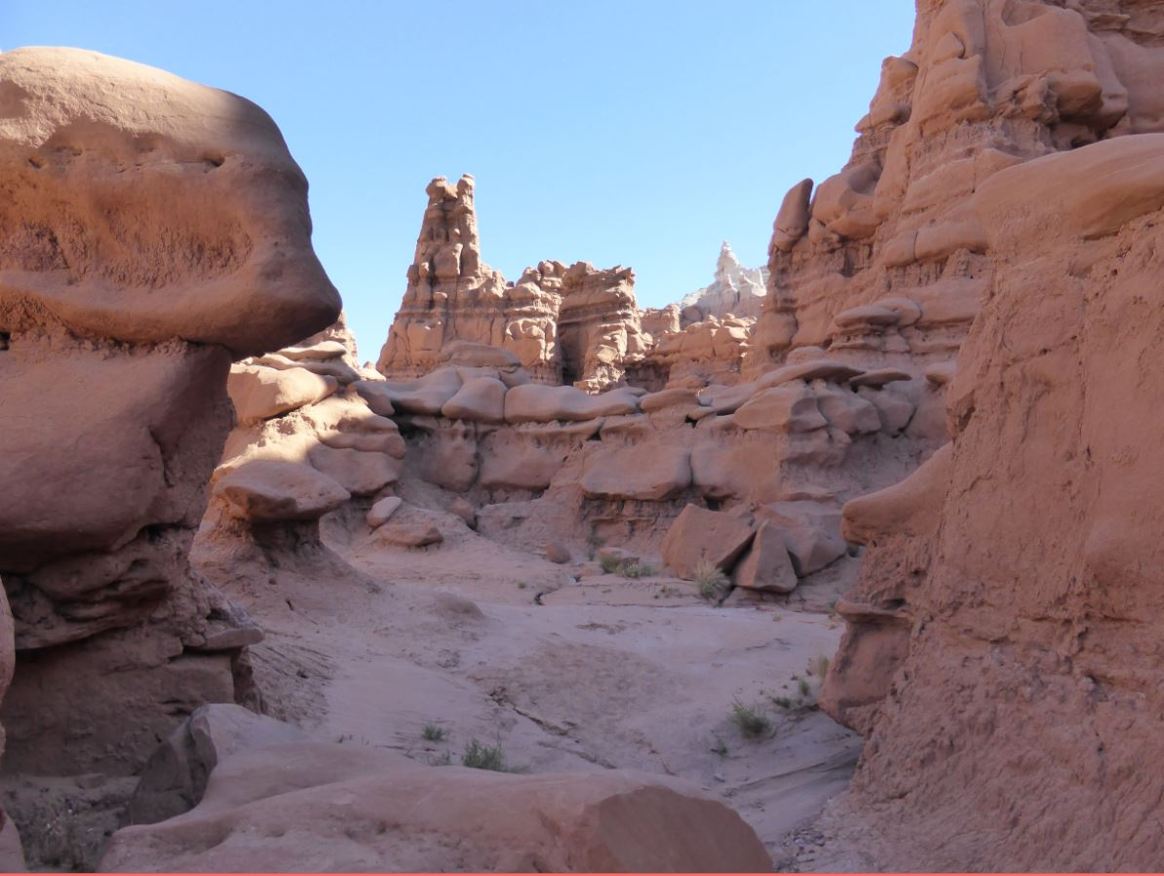

For those wishing for the greatest amount of solitude among the goblins, the Third Valley is the place to be. Its total expanse rivals that of the first and second valleys combined, and it shares aspects of both. This “valley” actually consists of several side canyons and washes that branch off from the central Red Canyon drainage, which begins to noticeably form a channel approximately one mile south of the observation point.

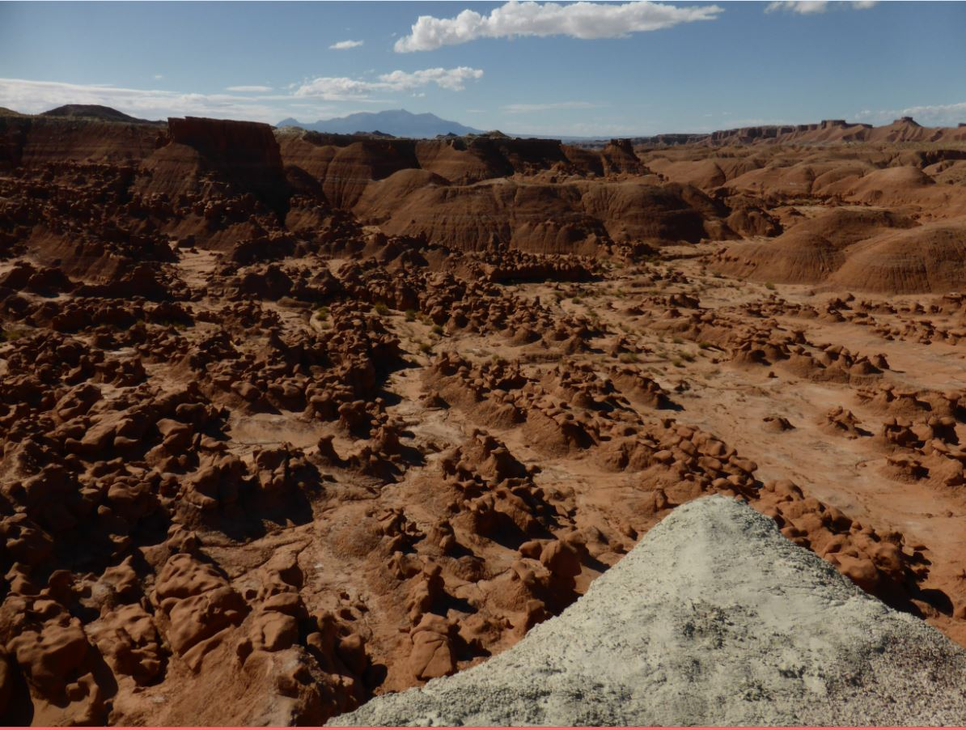
Above the Third Valley
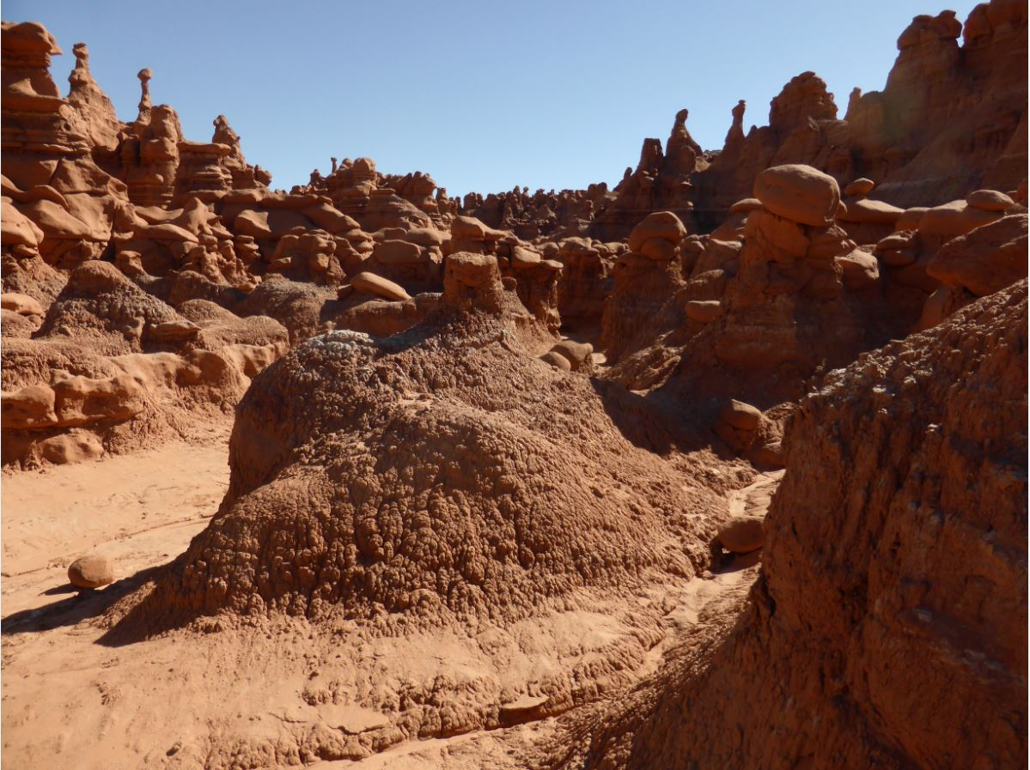
Inside one of the side canyons
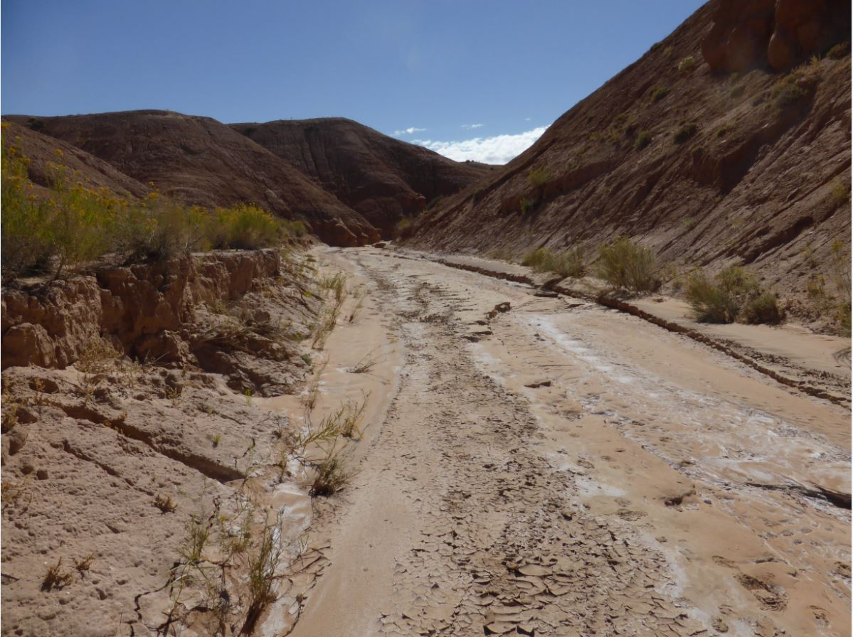
Red Canyon Drainage

Marked Trails
The Goblin’s Lair
Distance: 1.5 miles one way.
Difficulty: Strenuous
Hidden away on the park’s eastern boundary, beyond the cliffs that form the far wall of the Valley of Goblins, is a massive cavernous formation known as The Goblin’s Lair. Not truly a cavern, the “lair” is actually a beautiful slot canyon, the entrance of which has been sealed by rock fall. Depending on time of day, light may pour in through ceiling vents more than 100 feet above the chamber floor. Once a secret gem known only to a few, a marked trail now guides visitors to the “hiker’s entrance” of the lair. The trail begins at the observation point, and follows the Carmel Canyon loop before splitting off after 1/2 mile. Some moderate scrambling up scree slopes and over boulders is required. Caution is advised.
Permits for those wishing to rappel into the Goblin’s Lair are available at the visitor center desk. A $2 permit fee (per group) is charged for the maintenance of the route. Guided canyoneering tours are also available at Get in the Wild Adventures.

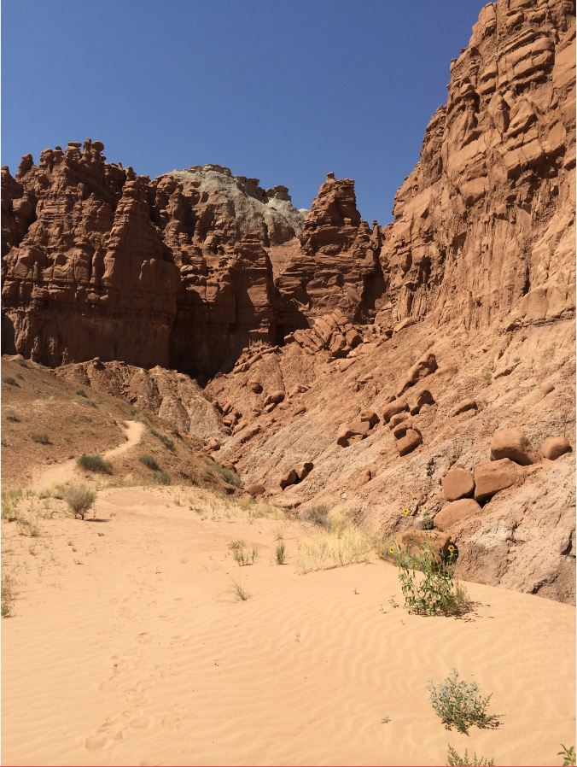
Approaching the Lair
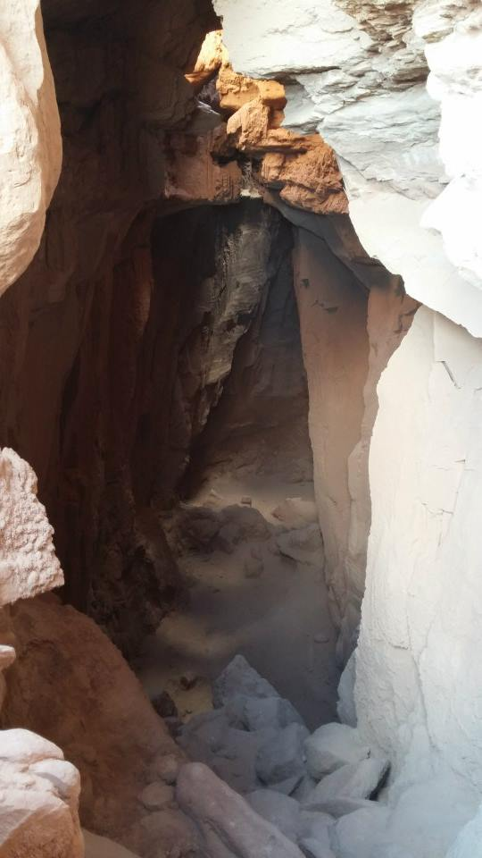
Descending into the chamber
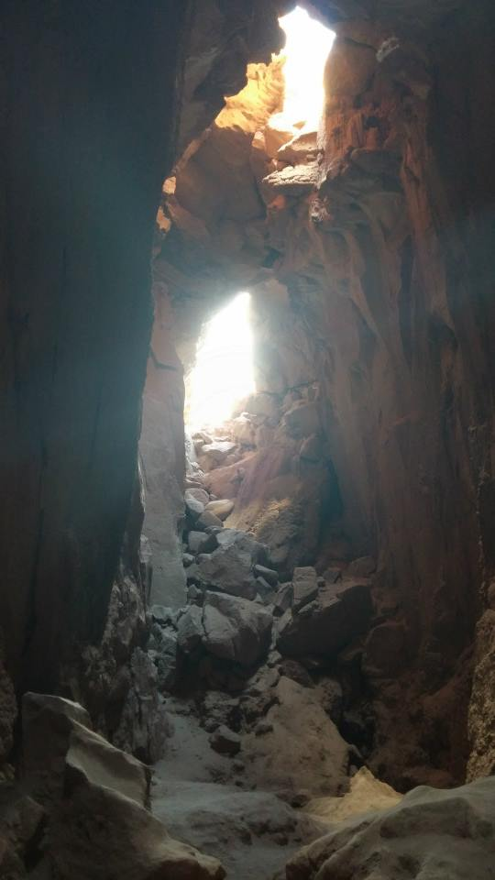
Inside the Lair.

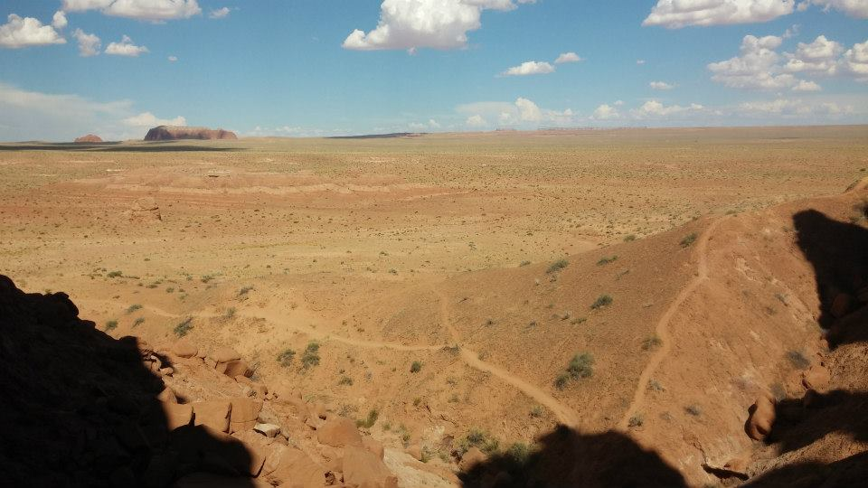
Outside: The San Rafael Desert
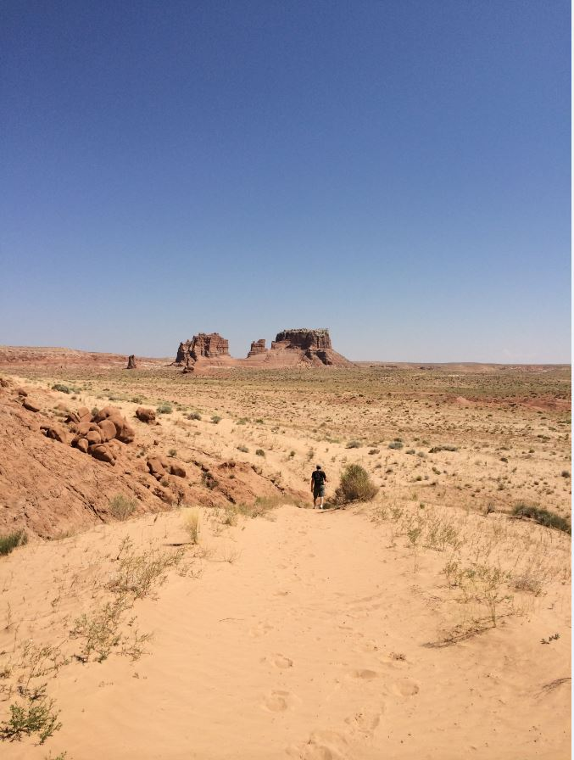
Molly’s Castle from the trail.

The Carmel Canyon Loop
Distance: 1.5 miles round trip
Difficulty: Moderate
While most visitors venture down the Carmel Canyon Loop only to access the Goblin’s Lair Trail, it is a beautiful hike in its own right. Especially scenic in the evening hours, this trail grants sweeping vistas of the Carmel goblin formation, the Molly’s Castle outcrop, the Three Sisters, and on clear days, even the La Sal Mountains far to the east. For those who lack the time to explore Little Wild Horse Canyon, Carmel Canyon does contain a short section of colorful narrows. Completing the entire loop requires some minor scrambling. Caution is advised.

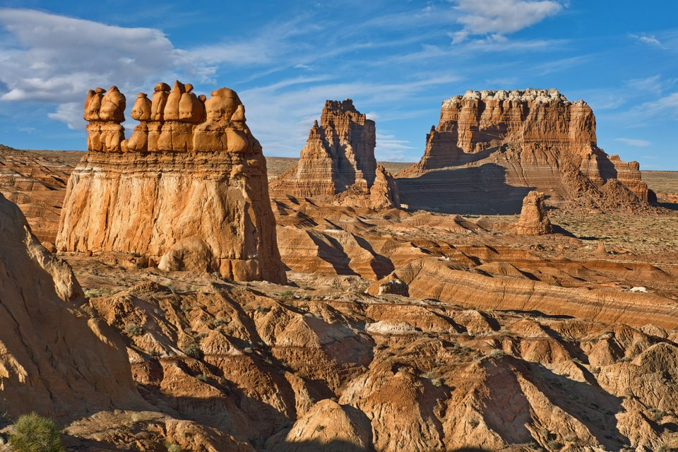
Carmel Formation & Molly’s Castle
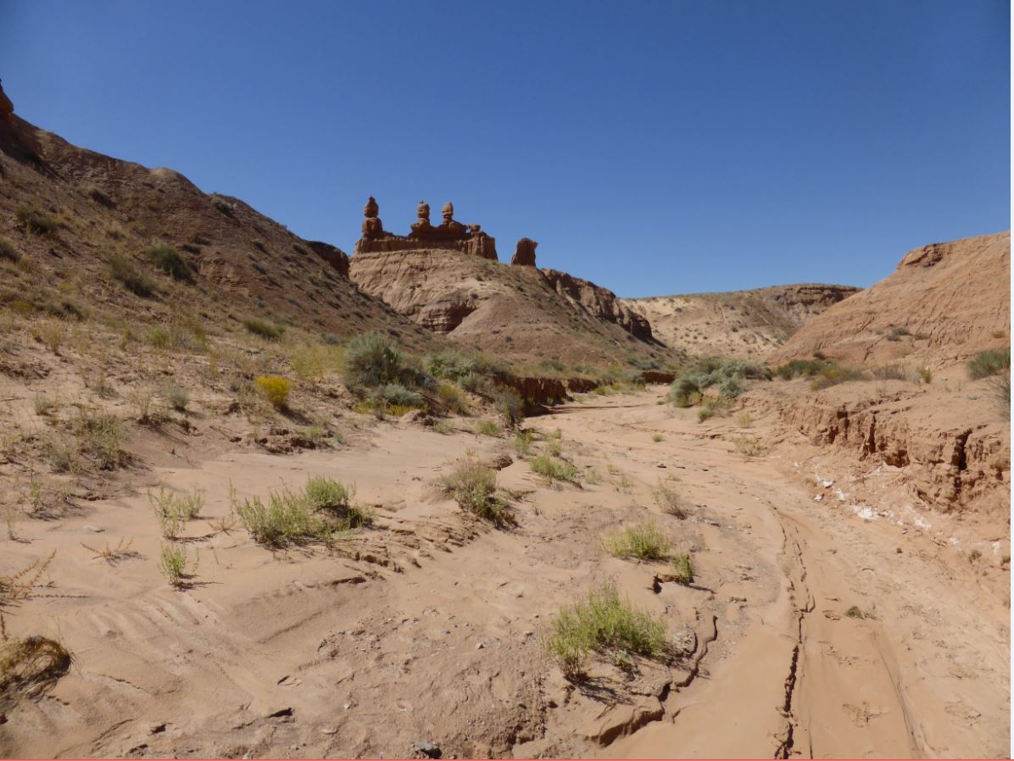
The Three Sisters from below
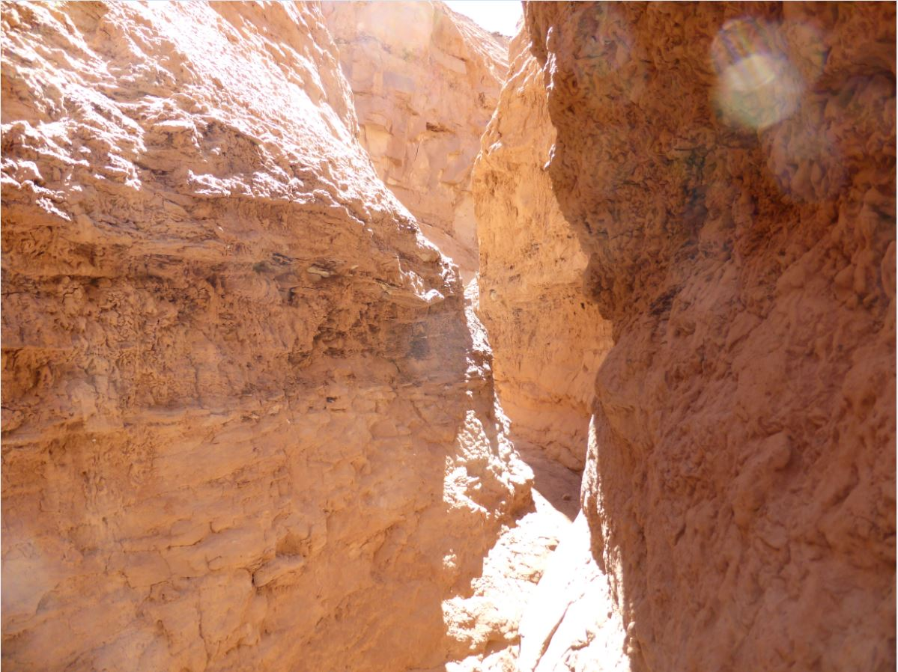
Carmel Canyon Narrows

Entrada Canyon
Distance: 1.5 miles one way
Difficulty: Moderate
The Entrada Canyon Trail begins at the group campsite and ends at the Valley of Goblins observation point parking lot. The canyon is named for the same layer of sand and silt stone that makes up the Valley of Goblins. For those spending the night in the park, it serves as a scenic alternative to driving. Along the way, hikers will pass by a number of interesting goblin formations that cannot be easily seen from any other vantage point. Please note that while there are toilet facilities at the observation point, there is no water available. Make sure to bring plenty with you!

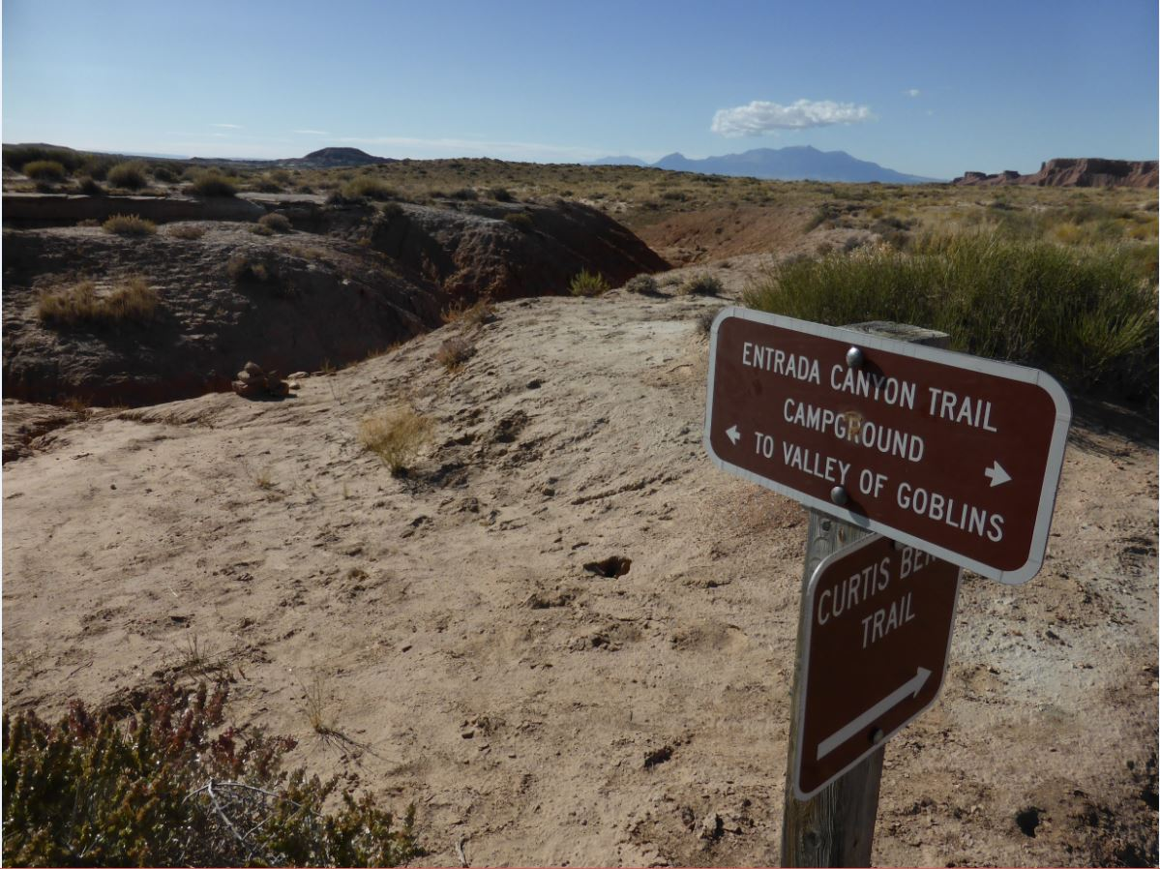
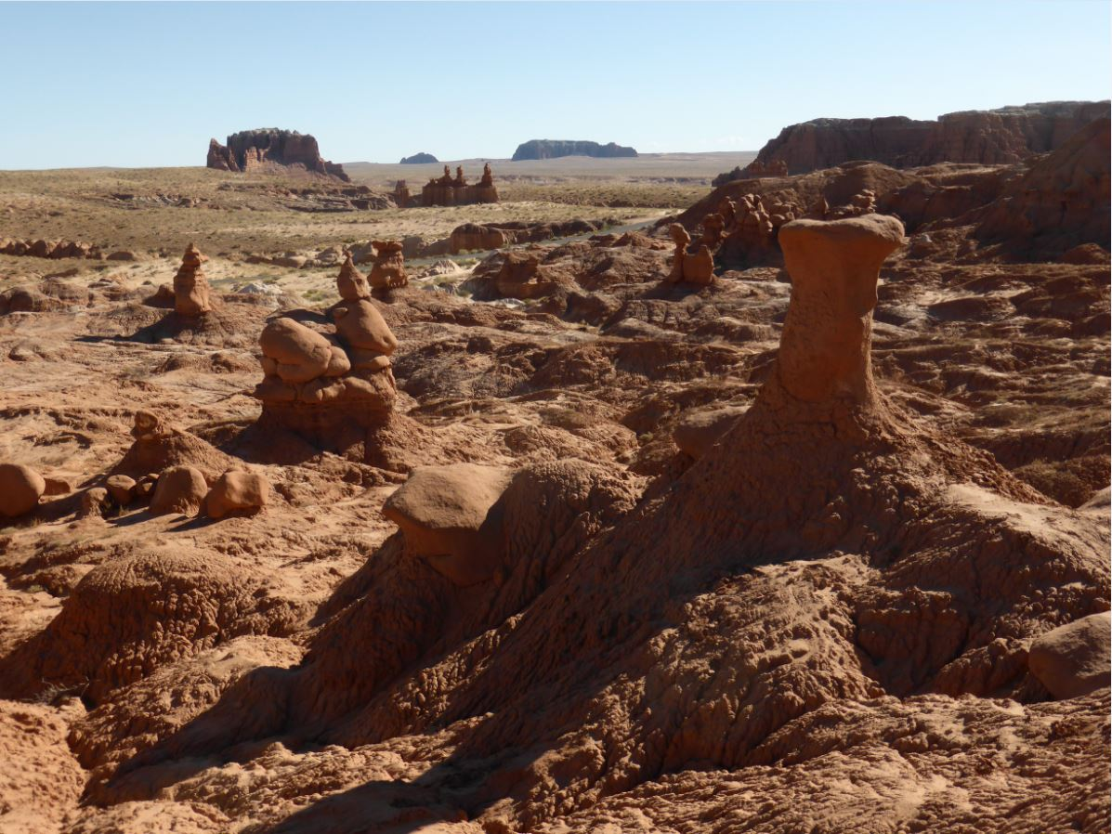
Scenes from the Entrada Canyon Trail
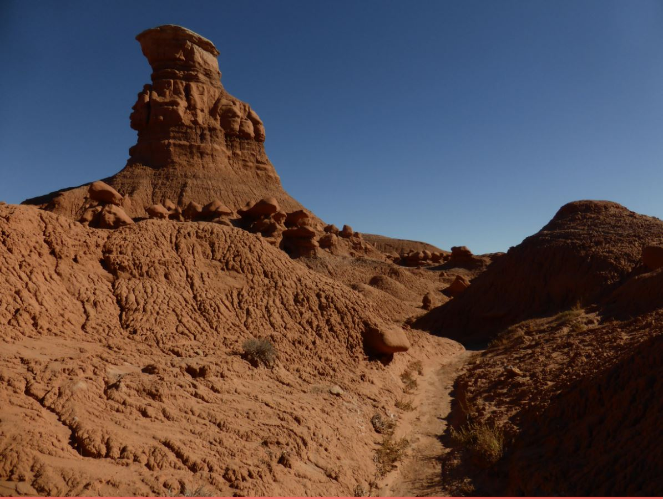

Curtis Bench Trail
Distance: 1.5 miles one way
Difficulty: Easy
The Curtis Bench Trail is accessed alongside the Entrada Canyon Trail and runs parallel to it, but at a higher elevation. It is named for the grey-green Curtis layer of sand and silt stone that covers many of the upland regions of the park. From this vantage point, hikers are awarded sweeping vistas of the Henry Mountains to the south, as well as the Valley of Goblins to the east. A marked cutoff trail leads down into the First Valley, allowing for a potential loop hike with the Entrada Canyon Trail. Doing so would amount to a trek of approximately four miles.

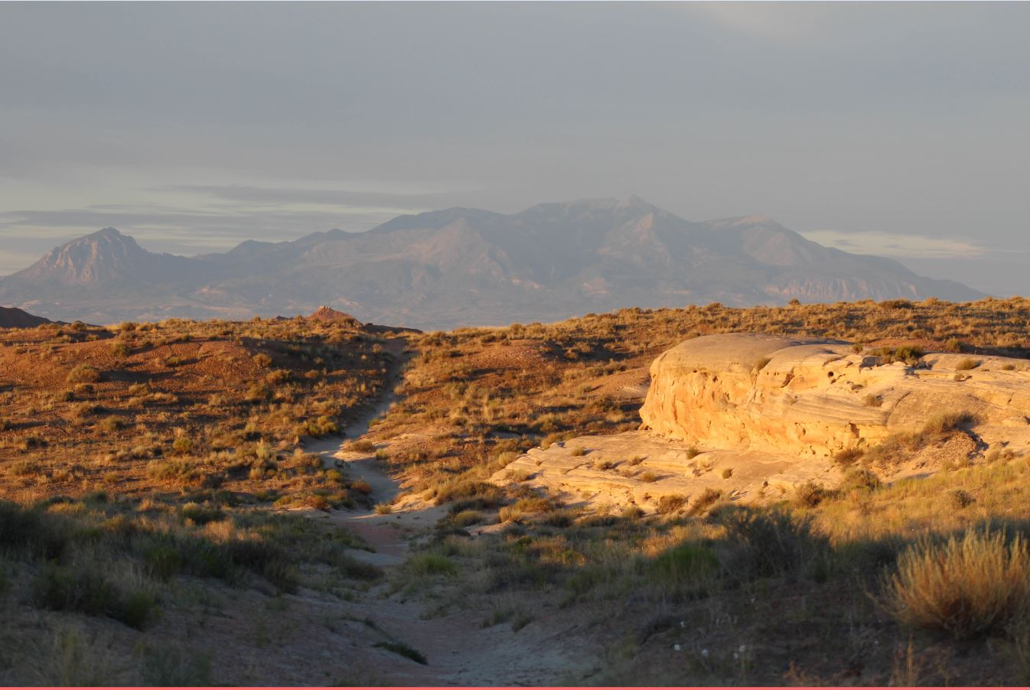
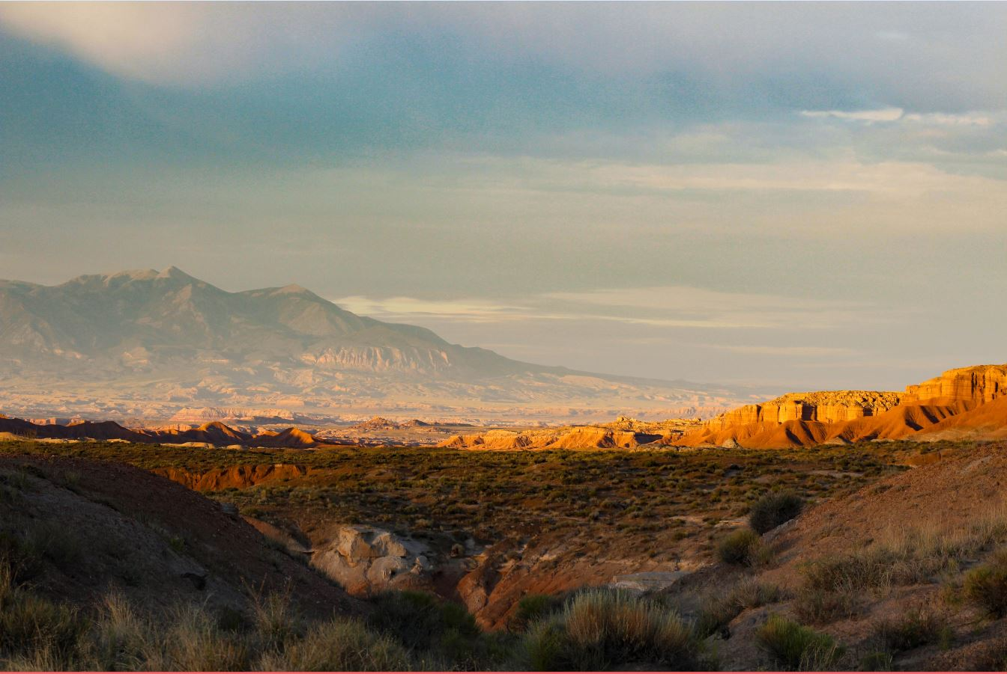
Views from the Curtis Bench Trail
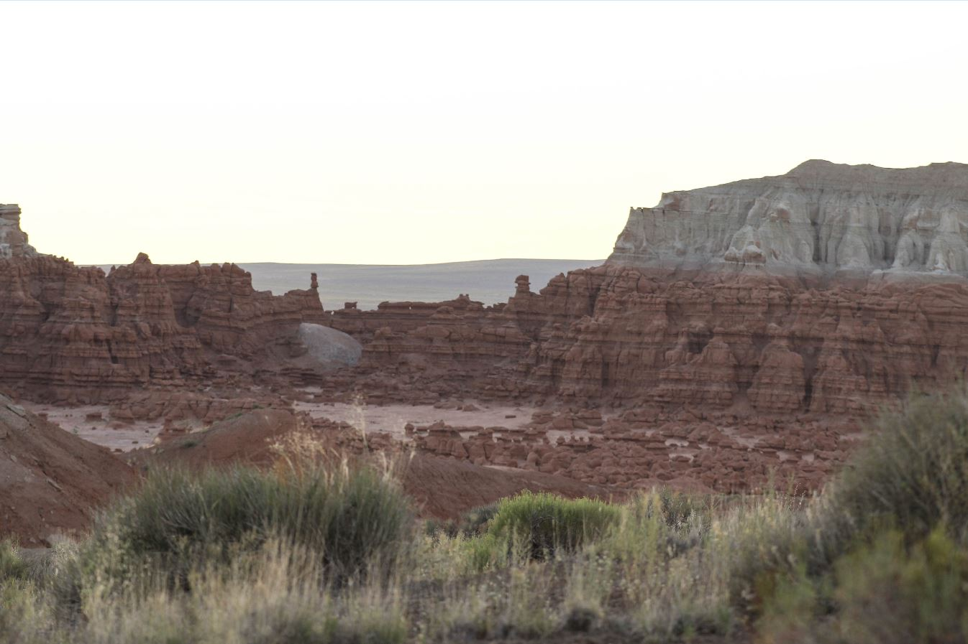

The Three Sisters
Distance: 250 yards, one way
Difficulty: Easy
The Three Sisters is the most iconic of all goblin formations within the park, and is found on many of the souvenir items available in the visitor center. Most visitors snap a photograph of it as they drive toward the observation point. For those wishing for a closer look, an unmarked but easy-to-follow trail does exist. Simply pull off into one of the nearby parking spots along the road and start walking. In addition to the Three Sisters, the trail also grants views of the Carmel Canyon drainage system, 100 feet below.

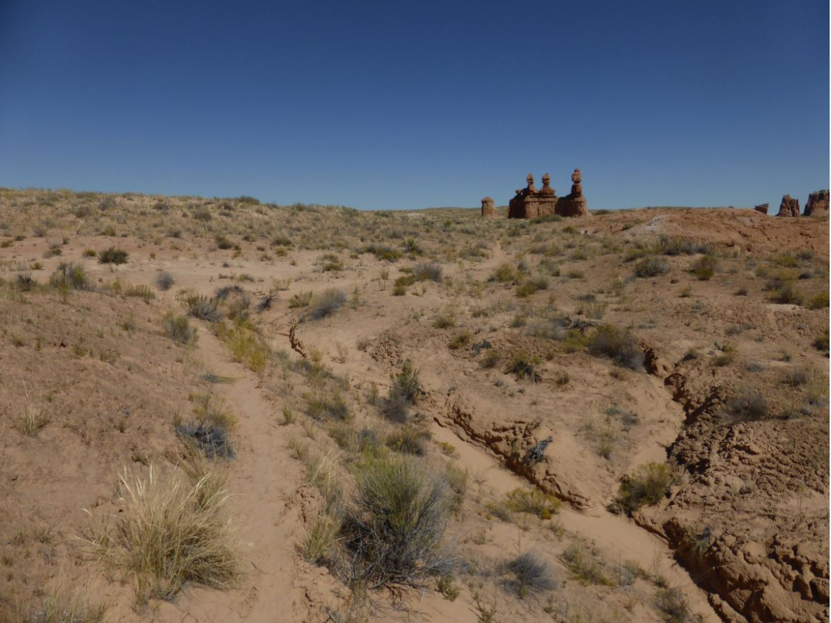
The trail
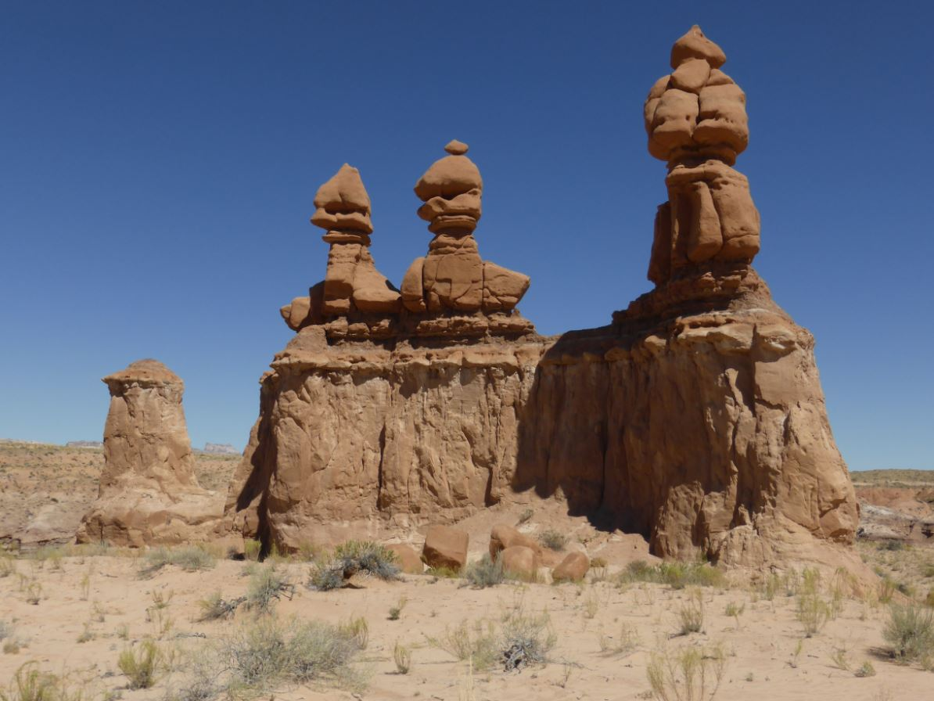
The Three Sisters
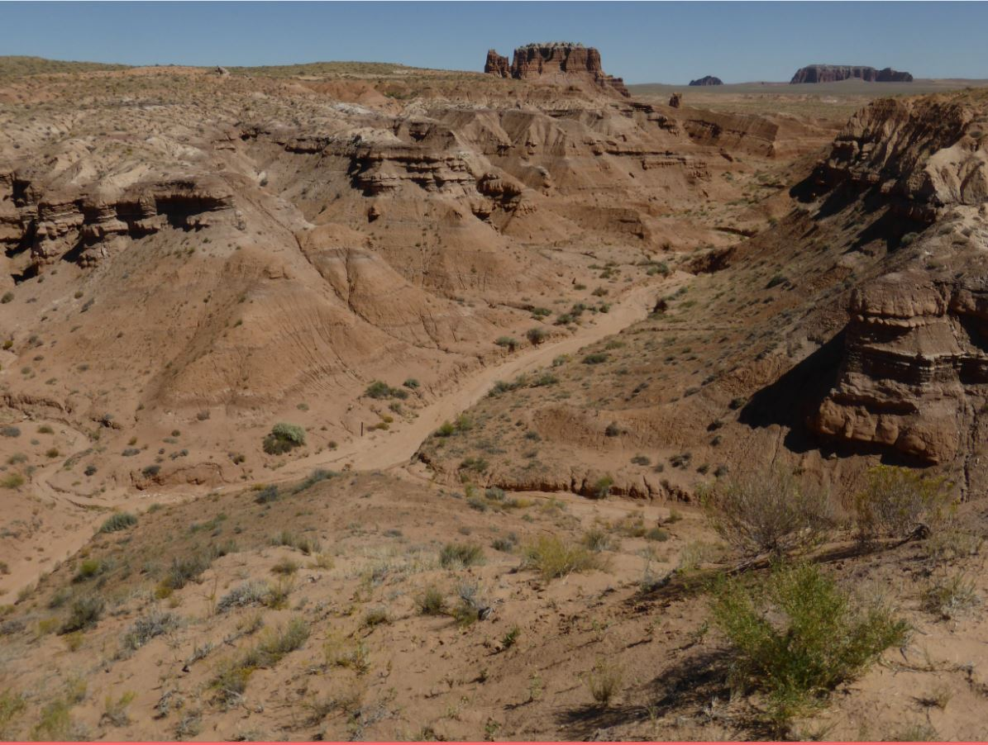
Carmel Canyon from above

